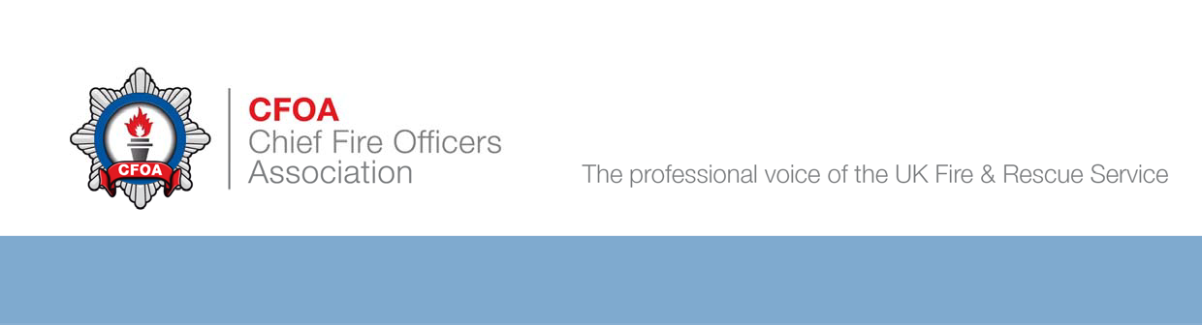This signed and completed form must be maintained and available for inspection by the Fire & Rescue Service/ Event Organiser/Council Officers at all times.

Fire Risk Assessment - Traders and Market Stalls
Please retain for your records. A copy does not need to be sent to CFOA

Name of Unit / Stall

Contact No. on site

Location on site

In order to comply with the Regulatory Reform (Fire Safety) Order 2005, you MUST complete a Fire Risk Assessment of your stall or unit.
The Risk Assessment needs to identify the fire hazards and persons at risk, you must endevour to remove or reduce these risks and protect people from fire.
Failure to comply with this requirement will result in you being removed from the site.
You must be able to answer YES to the following questions.

You must undertake a Fire Risk Assessment for your unit, which must be suitable for the circumstances. You do not need to use this form, and may use another method if you wish,
however, this form is considered to be suitable for most standard market stalls and units

- Are adequate exits provided for the numbers of persons within the unit or stall? (Are your staff and customers able to evacuate easily if the normal exit is blocked?)
Yes
No

- Where necessary, are there sufficient directional signs indicating the appropriate escape route and do they comply with current regulations?
Yes
No

- Are the exits maintained available, unobstructed, and unlocked at all times structures/premises are in use.
Yes
No

- If the normal lighting failed would the occupants be able to make a safe exit?
Yes
No
(Consider back up lighting such as torches)

- Do you have an adequate number of fire extinguishers/fire blankets available in prominent positions and easily available for use?
Yes
No

- Has the fire-fighting equipment been tested within the last 12 months?
Yes
No

- Have your staff been instructed on how to operate the fire-fighting equipment provided?
Yes
No

- Have your staff been made aware of what to do should an incident occur, how to raise the alarm, evacuate the unit, and the exit locations?
Yes
No

- Have you identified combustible materials that could promote fire spread beyond the point of ignition such as paper/cardboard, bottled L.P.G. etc. and reduced the risk of them being involved in an incident?

Yes

No

- Have you identified all ignition sources and ensured that they are kept away from all flammable materials?
Yes
No

- Are the structure, roofing, walls and fittings of your stall or unit flame retardant?

Yes

No

- Are you aware that you must not stock or sell certain items, i.e. fireworks, garden flares etc.?
Yes
No

- Do you have sufficient bins for refuse?
Yes
No
Yes
No
- Is all refuse kept away from your unit/premises?

- Are you aware that petrol generators are not permitted on site
without prior permission from the organizers and a full risk assessment?
Yes
No

If you use LPG
NA
- Do you have an inspection / gas safety certificate for the appliances and pipework? (copy to be available for inspection)
Yes
No
NA
No
Yes
- Are the cylinders kept outside, secured in the upright position and out of the reach of the general public?
NA
No
Yes
- Are appliances fixed securely on a firm non-combustible heat insulating base and surrounded by shields of similar material on three sides?

- Are the cylinders located away from entrances, emergency exits and circulation areas?
Yes
NA
No

- Are the gas cylinders readily accessible to enable easy isolation in case of an emergency?
No
Yes
NA

- Do you ensure that all gas supplies are isolated at the cylinder, as well as the appliance when the apparatus is not in use?
Yes
NA
No

- Do you ensure that only those cylinders in use and a single spare cylinder are kept at your unit/stall?
Yes
NA
No

- Is a member of staff, appropriately trained staff in the safe use of LPG, present in the unit / stall at all times?
NA
No
Yes

If the answer to any of the above questions is “NO”, Please detail the actions you have taken to remedy the situation.

Stallholder / Responsible Person :

Signature Print Name Date

Designation : Company :

PLEASE NOTE

THIS DOCUMENT DOES NOT PRECLUDE YOU FROM POSSIBLE PROSECUTION OR REMOVAL FROM THE SITE BY THE ORGANISERS,
SHOULD A SUBSEQUENT INSPECTION REVEAL UNSATISFACTORY STANDARDS.

